Interferomatic Manual

Welcome!

Interferomatic is the software that we use to get data with our dual frequency comb spectrometer.

It’s easy to use once you know the basic steps to get a baseline, collect data, and analyze those data.

Basic Steps

1. First, start Interferomatic. Do this by clicking its icon on the desktop, or run these commands in the terminal:

cd

cd interferomatic

python3 main.py

2. Now we need to get a baseline. IMPORTANT! This is required if you want to get a reading of some material sample and look at its transmission/absorption lines. Without a baseline, you will get a lot of irrelevant junk that makes it harder to see these lines. However, if you want to analyze the raw, whole, incoming spectrum of the laser, then you do not want a baseline and so you can skip this skip. This step also only applies if you want to collect data by averaging interferograms. If you are monitoring the live signal or collecting bulk data then this baseline step doesn’t apply.

To get a baseline,

- click the “Choose mode” dropdown and select “Baseline for Average Interferograms”
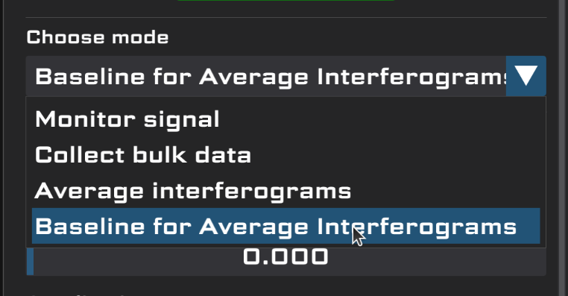

- choose a good number of at least 1000 or so for the number of interferograms to collect so that you don’t have excess noise. Note that our setup generates approximately 25-50 interferograms per second, so 1000 interferograms will take about half a minute

- choose a good file name to save your baseline to in the “Save file” selector

- change the rest of the settings to match what you’ll use later when averaging interferograms

- click the “Start” button to start collecting data and it should now say “Stop”

- wait

- once collection has finished, the “Stop” button should turn back to “Start”

- make sure the baseline is saved to the file location specified

3. Finally, let’s collect our data by averaging interferograms.

- click the “Choose mode” dropdown again and select the “Average Interferograms” option

- change the interferograms to collect to be much higher. 100000 (one hundred thousand) is a common value for our experiments

- change the “Save file” location to be a different file than the baseline

- click the “Start” button to start collecting data. It should turn into “Stop” like with getting the baseline

- wait

- once the data collection is done, once again, make sure the data is saved in the specified file

Example: Triangle wave

Let’s put our skills to use with a different kind of wave to show how Interferomatic works with other inputs, not just interferograms.

Read every step!

Start Interferomatic.

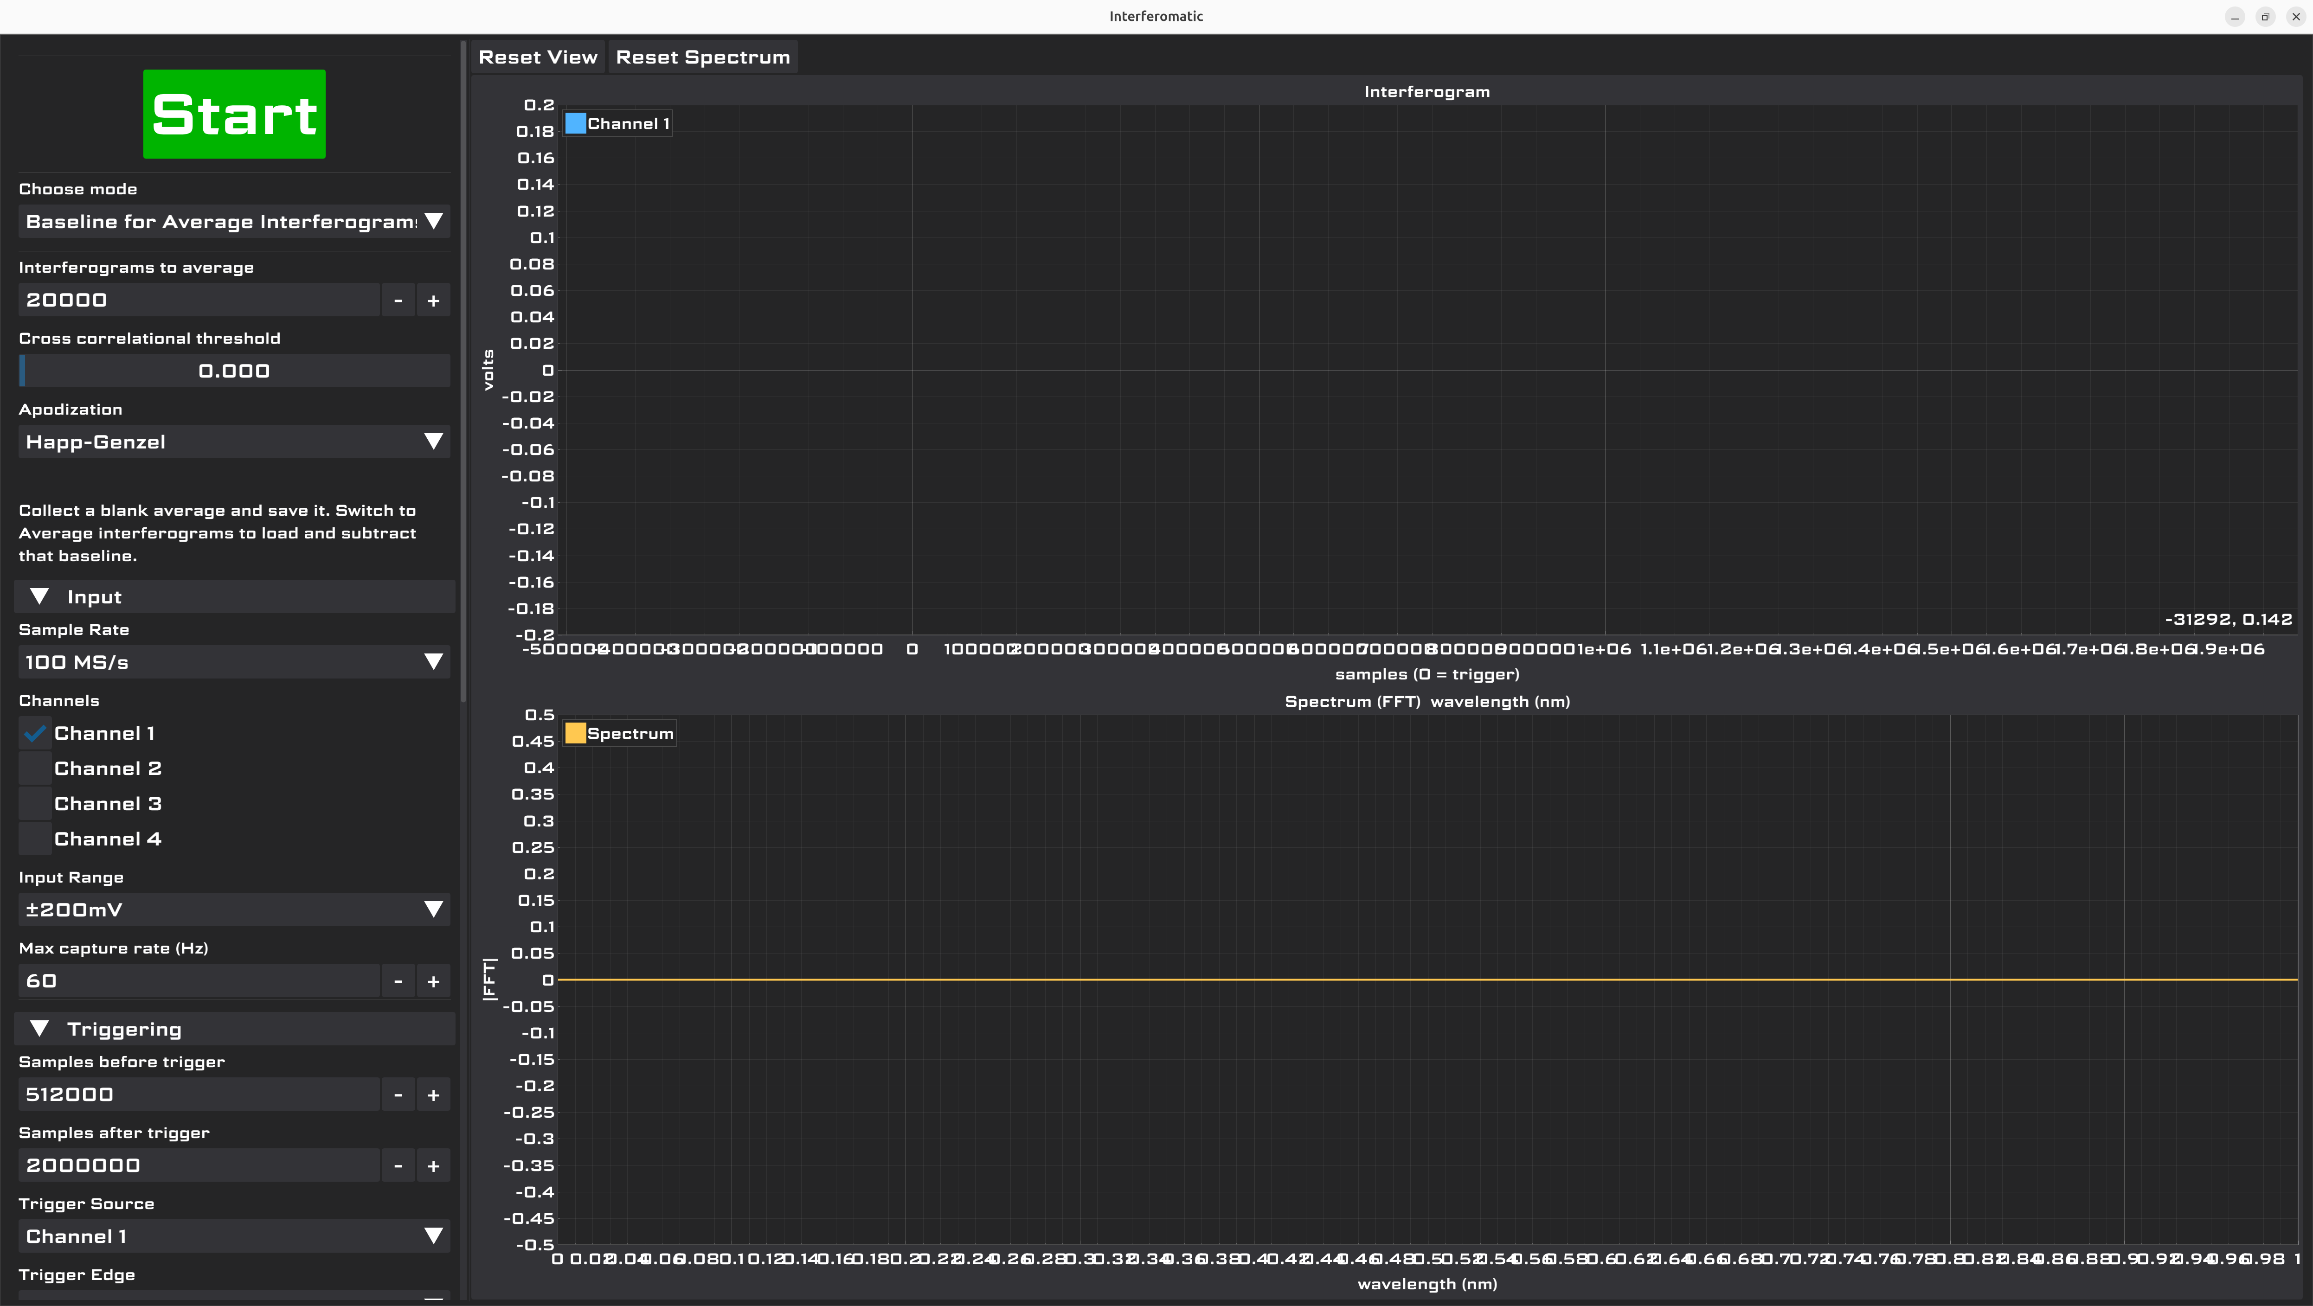
Let’s collect a baseline for our triangle wave signal.

Apply these settings:

Interferograms to average: 20000
Cross correlational threshold: 0.500
Apodization: Happ-Genzel
Sample rate: 100MS/s
Channels: Channel 1 checked
Input range: +-5V
Max capture rate: 60Hz
Samples before trigger: 512000
Samples after trigger: 2000000
Trigger source: Channel 1
Trigger edge: Rising
Trigger threshold: 12%
Reference clock: Checked
Spectrum x axis: Wavelength (nm)
Rest of Spectrum: Leave default
Save to file: Checked
Save file: Choose a good filename. One you can use is this: /home/gage/Desktop/triangle_baseline.csv
Save format: CSV
When to save: On finish

Note that many of these settings are probably already set, because they’re the default.

Some of them don’t matter for our triangle wave but this shouldn’t be a problem for our example.

Your Interferomatic window should now look something like this:
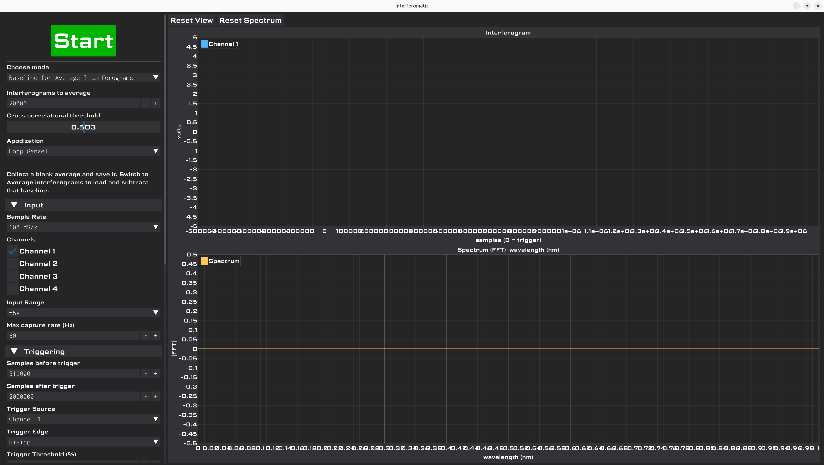

Click the Start button.
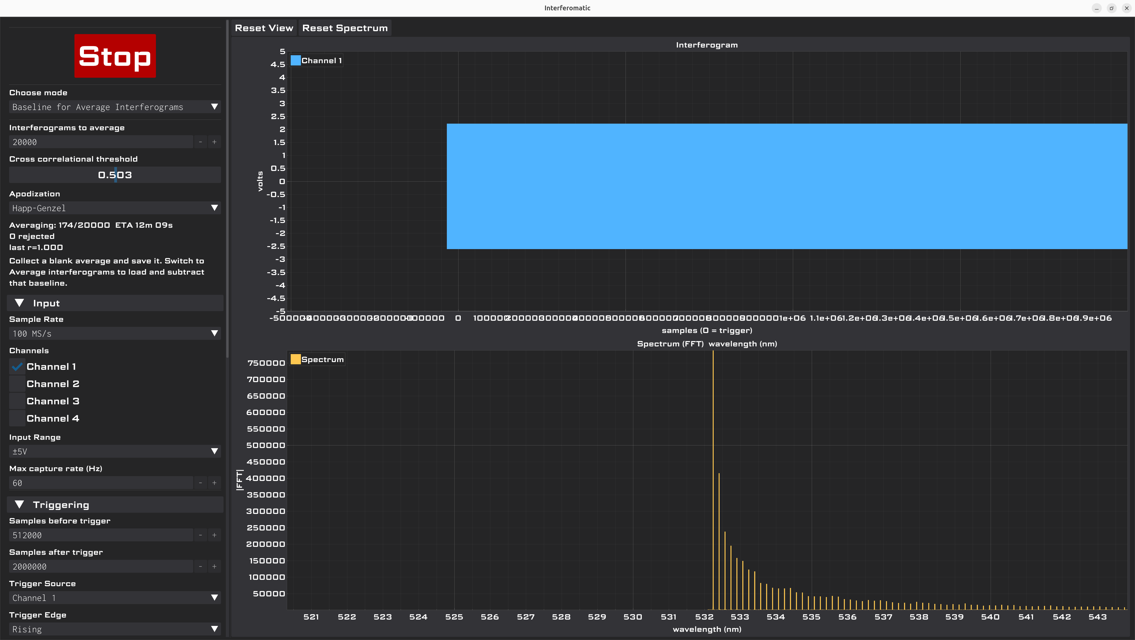

That signal monitor looks kind of terrible.

To expand it, first zoom in so the wave fills the vertical axis. Then, right click the x axis (the samples one).

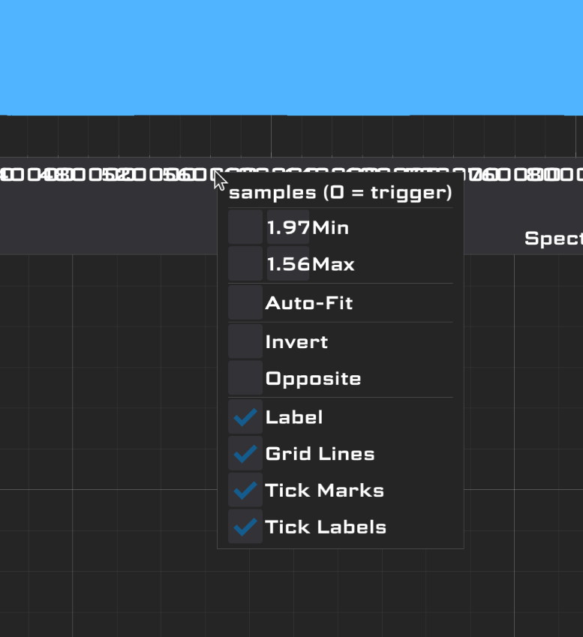

Drag the little box next to the “Min” or “Max” text to expand the chart in the x axis.

Once you’ve done that enough, your window should look like this.

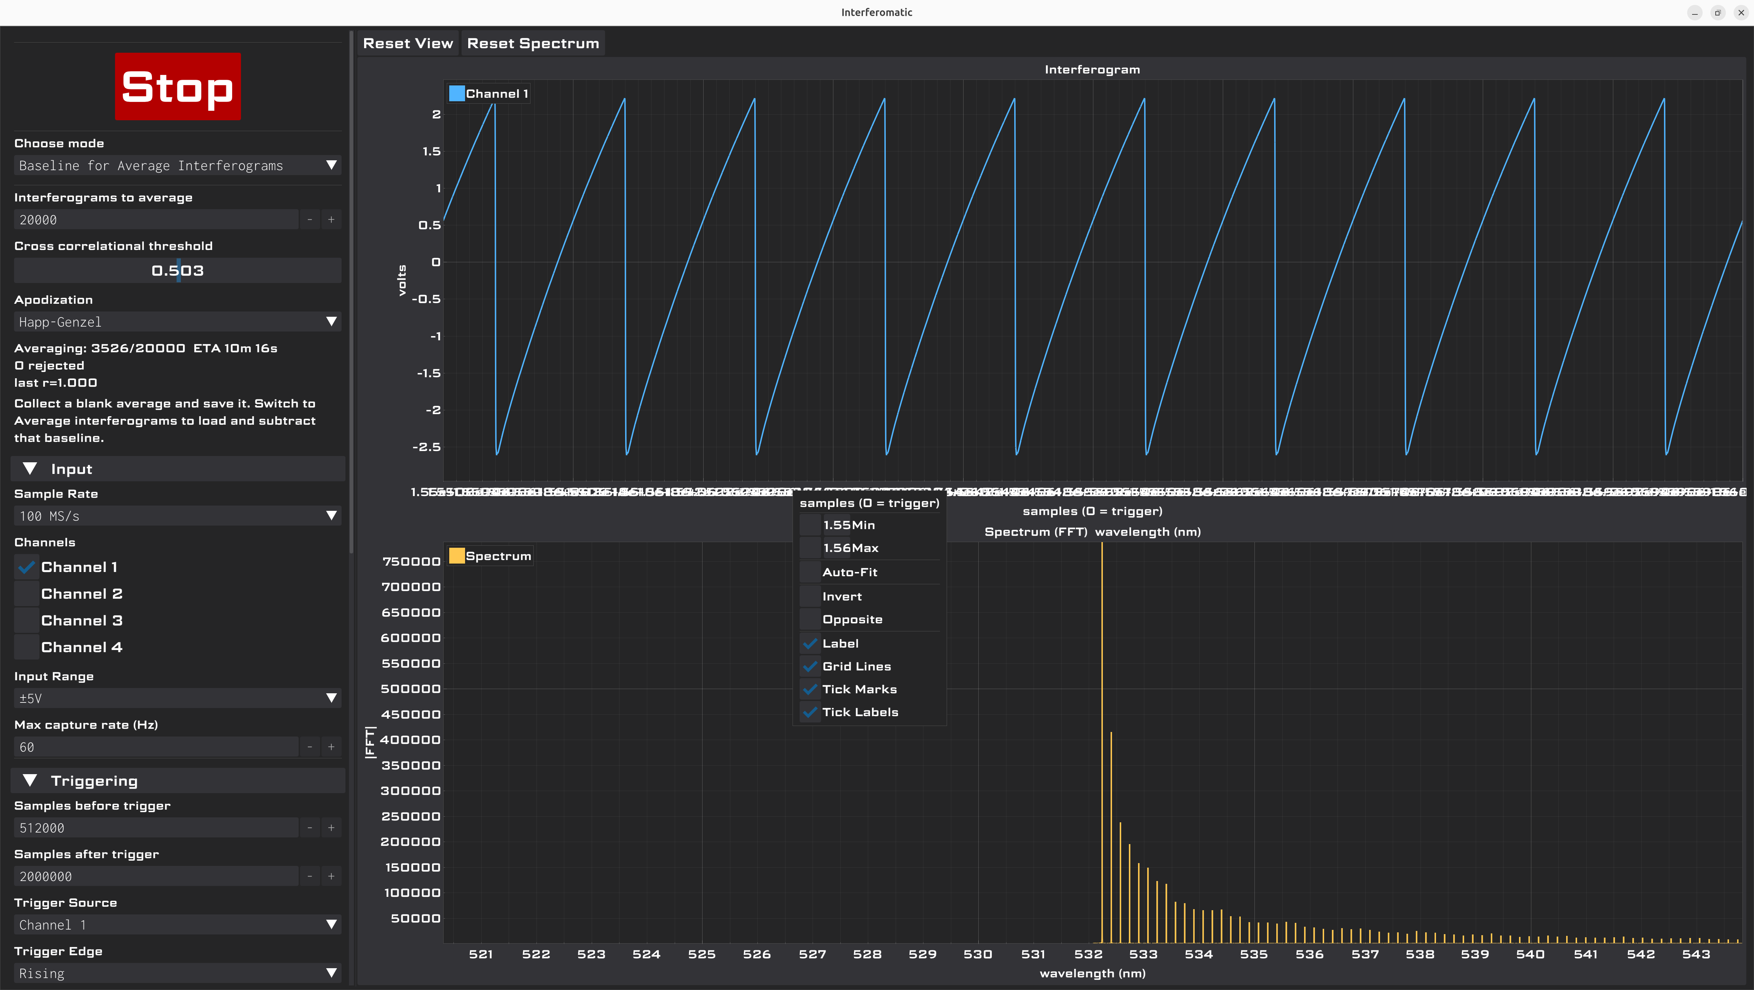

That’s better. Click outside the little box to close it.

Now wait for the baseline to be collected.

If Interferomatic pauses and creates some weird crash error, just wait and it’ll continue. This is a bug that we know about.

Finally, Interferomatic will stop once it’s collected all 20000 “interferograms” (really, samples of data in this case).

Look for the saved file in the place where you specified it to be stored.

Open it in the text editor and it should look something like this.

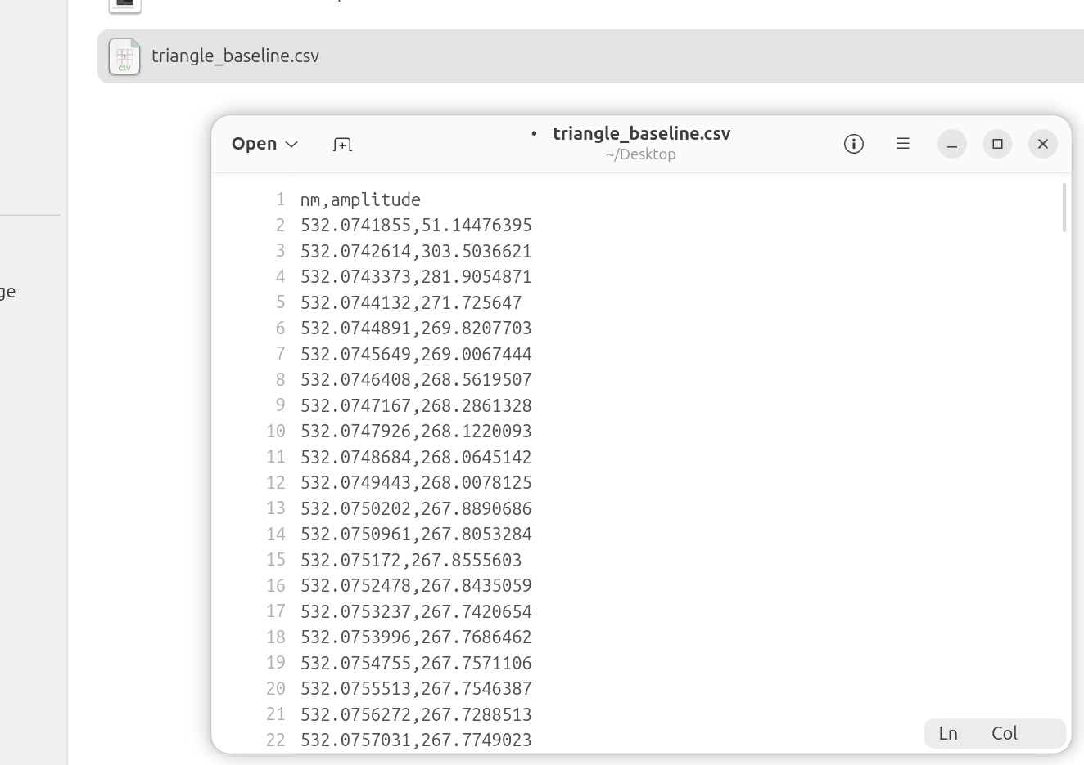
Its size should be in the 26.6MB range.

Now, go back to Interferomatic and click the “Choose mode” dropdown.

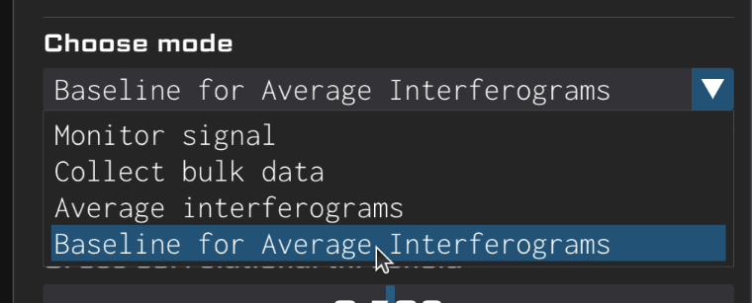
Click the “Average interferograms” mode.

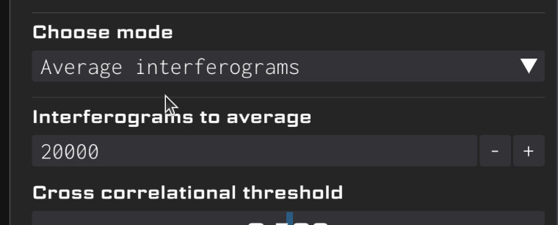
Now, let’s load the baseline that we just collected.

In the “Baseline file” box, enter the same filename that you entered when saving the baseline.

If you want to, click the “Load Baseline” button to choose your file graphically.

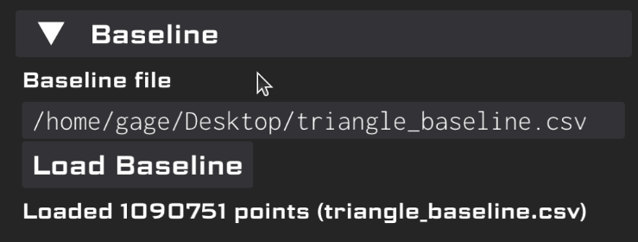
Now, you have two options. If you’d like to save the new results, change the save file by changing the filename in the “Save file” text box. If not, uncheck the “Save to file” checkbox.

Click the “Start” button to start collecting data with respect to our baseline.

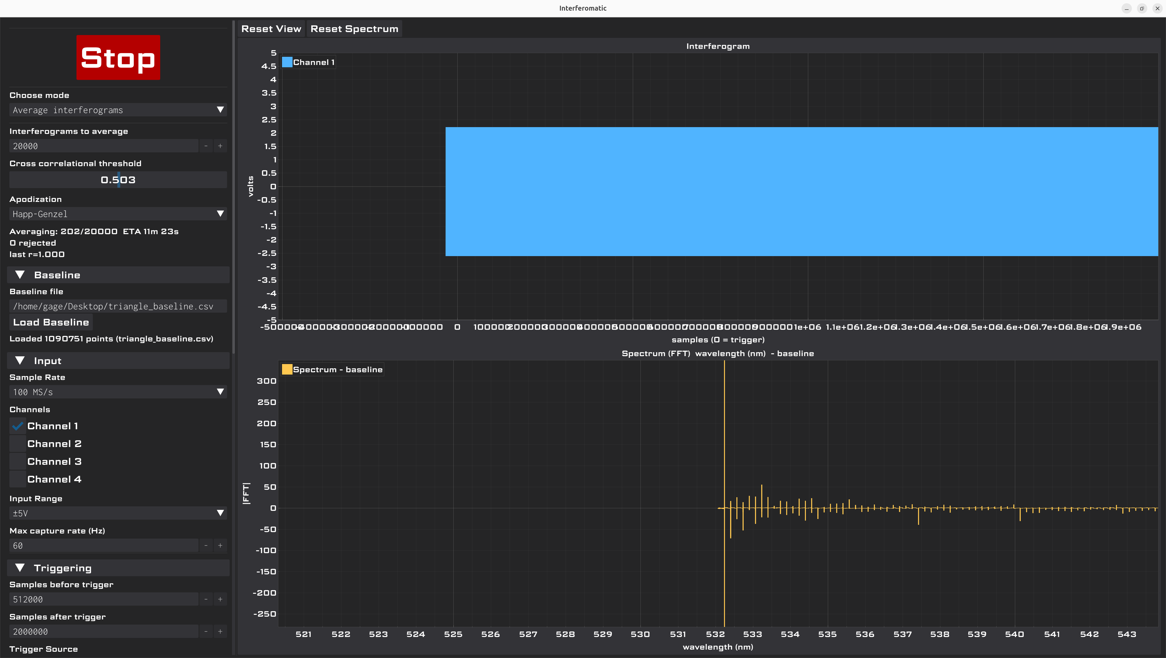
What you see in the Spectrum chart is the difference between the baseline and the current averaged signal.

Don’t fret if it looks weird, because we are essentially comparing something to itself, so all you’ll see is noise.

Wait for Interferomatic to finish collecting data.

If you’ve opted to save a file, your result will live in the specified file location.

Otherwise, the result will only be displayed.

You’ve reached the end of this example. The real fun is to be had with the resulting data such as spectral composition analysis among other uses.

